Project 1 - The Distributed Coordination Function (DCF) of 802.11

Cedric Destin

Royan Vincent Tuscano

# Introduction

This project describes the functionality of the 802.11 under two scenarios, **concurrent communications** and **hidden terminals** w/ the parameters described in Table 1.

|  |  |  |  |
| --- | --- | --- | --- |
| Parameter | Value | Parameter | Value |
| Data frame size | 1,500 bytes | ACK, RTS, CTS size | 30 bytes |
| Slot Duration | 20 µs | DIFS duration | 40 µs |
| SIFS Duration | 10 µs | Transmission rate | 6 Mbps |
| CW0 | 4 slots | CWmax | 1024 slots |
| λA, λC | {50, 100, 200, 300} frames / sec | Simulation time | 10 sec |

Table : Simulation parameters

The concurrent communications is illustrated in Figure 1, in this case, the two channels are in the same collision domain/transmission range. The data will be sent using the Distributed Coordination Function (DCF) and we will use two different topologies, with and without Virtual Carrier Sensing.

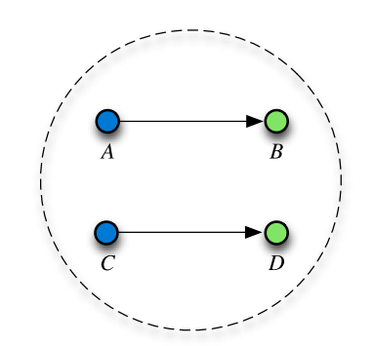

Figure : Concurrent Communication topology

The hidden terminal topology is illustrated in Figure 2, in this case, the two channels are **not** in the same collision domain/transmission range, however the receiver () is still in each of the transmitters. The data will also be sent using the Distributed Coordination Function (DCF) and we will two topologies, with and without Virtual Carrier Sensing.

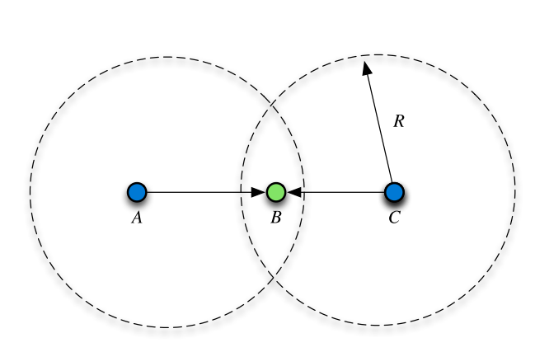

Figure : Hidden Terminal topology

## Objective

The objective of this project is to analyze the performance of the two topologies under the no virtual carrier sensing and the virtual carrier sensing ability used within the topologies. The following parameters will be used to analyze the performance of the topologies:

|  |  |  |
| --- | --- | --- |
| Throughput *T (Kpbs)* vs rate λ (*frame/sec*) | Number of collisions *N* vs. rate λ (*frame/sec*) | Fairness Index vs rate λ |
| Node A, implementation 1 & 2 | Node A, implementation 1 & 2 | Scenario A & B  Implementation 1 & 2; λA = 2λC |
| Node C, implementation 1 & 2 | Node C, implementation 1 & 2 |
| Node A, implementation 1 & 2; λA = 2λC | Node A, implementation 1 & 2; λA = 2λC | Scenario A & B  Implementation 1 & 2; λA = 2λC |
| Node C, implementation 1 & 2; λA = 2λC | Node C, implementation 1 & 2; λA = 2λC |

## Tasks Planner

|  |  |  |
| --- | --- | --- |
|  | Royan Vincent Tuscano | Cedric Destin |
| Task 1 | concurrent communications  w/ virtual carrier sensing | concurrent communications  w/o virtual carrier sensing |
| Task 2 | hidden terminals  w/o virtual carrier sensing | hidden terminals  w/ virtual carrier sensing |